MINISTRY OF HEALTH OF THE RSFSR

STAVROPOL STATE MEDICAL INSTITUTE

As manuscript

**AMINOV Boris Mihaylovich**

ELECTRICAL PARAMETERS OF THE TISSUES UNDER COMBINED IMPACT OF

CERTAIN PHYSICAL FACTORS

ON THE BODY

(exposure to total sub-lethal x-ray exposure, insolation, exercise and

transfusions of the blood

irradiated in isolation)

14.00.16 - Pathophysiology

ABSTRACT

of the dissertation for the degree of

candidate of medical sciences

Stavropol - 1974

UDC 612.014.422: 612. 014. 44 + 613. 731 + 615. 381 + 616 - 001. 28 - 084.

This work was executed at the Chair of normal physiology (head of the Chair, associate professor M.K. Rakhimova) and in the clinical hospital named after F. Khojaev (headed by doctor S.K. Karimov) at the Samarkand Medical Institute named after Acad. I.P. Pavlov (rector - Prof. U.K. Vakhabova), and at the Department of X-ray Radiology (head - Prof. A.I. Nesis) of the Stavropol Medical Institute (rector -

associate professor Yu.P. Mikhaylichenko).

Scientific supervisors:

candidate of medical sciences; associate professor Irgashev Kh.H.

Honored Inventor of the Kazakh SSR, MD,

professor Nesis A.I.

Scientific consultant, MD, Vasilenko Yu.K.

Official opponents:

medical doctor, professor Ochelenko L.N.

candidate of medical sciences, associate professor Pshenichny I.P.

Leading Enterprise - Pyatigorsk Research Institute of Balneology and Physiotherapy of the Ministry of Health of the RSFSR

The Abstract is distributed " " _____________ 1974

Defense of the thesis will be held on "___" _________ 1974 at

"____" o'clock at the meeting of the Scientific Council of Stavropol State Medical Institute, 310 Mira St., Stavropol

The dissertation can be found at the library.

Scientific Secretary of the Council, professor

O.P.Krylova

The increasing frequency and intensity of ionizing radiation exposure of the population is an almost inevitable negative factor inherent to technical progress in the 20-th century. The effect of ionizing radiation on the body is often combined with various kinds of physical loads, and in the conditions of southern latitudes, there is also intensive insolation. Such combinations of the effects of various agents on human body may also result from the use of thermonuclear weapons.

Despite the problem importance, there is still no consensus on the effect on the body of ionizing radiation in combination with other physical agents. These issues are of particular interest in connection with the emerging opportunity to influence a number of pathological conditions by intense ionizing irradiation of one of the body's systems - peripheral blood (*E.P. Cronkite, e.a.*, 1962; A.I.Nesis, 1966, e.a.).

Comprehensive studies of a number of researchers of Samarkand and, more recently, Stavropol Medical Institutes, identified some aspects of the effect of transfusion of isolated irradiation blood (IIB) on transplant immunity (A. Aslanov, A. Katanov), general and local allergic reactions (A. Akhrorov, A.Orzykulov, G. Melnikov), metastases of malignant tumors (V. Danilyan) and others.

A group of researchers studied the joint effect on the body of general radiation exposure and transfusions of isolated irradiated blood, including under various conditions of insolation and physical load.

The impedance measurement method, reflecting the in vivo functional condition of submicroscopic structures, was chosen as one of the tests for the severity of changes in the tissues.

In this respect, we were challenged by several tasks:

1. Find out the patterns of changes in electrical characteristics of various systems in the body after general sub-lethal X-ray irradiation.
2. Distinguish the impact of repeated multiple physical loads and insolations on the animals irradiated with X-rays.
3. Determine the electrical conductivity of the tissues after transfusion of the isolated irradiated blood and the general radiation effect on the body, as well as to compare the data obtained under different combinations of the above-mentioned factors.

Object and

methodology

of the research

The experiments were carried out on 379 rats and 122 pigeons. The rats were divided into three groups. In one of them, the animals underwent only general sub-lethal X-ray irradiation in order to ascertain the nature of changes in the electrical conductivity of the organs at various times following radiation exposure. The remaining two groups of rats and pigeons were intended to study the combined effects on the body of x-ray irradiation and some other physical factors (insolation, physical exercise and transfusions of isolated irradiated blood).

In each of the combined series of experiments, there was a control subgroup, as well as animals exposed only to general X-ray exposure, the impact of only one of the physical factors we employed and a subgroup with the combined effect of general X-ray exposure and one of the additional physical agents. The electrical parameters of the heart and skeletal muscles, liver, spleen and some other organs were examined.

The electrical resistance of tissues was measured by low-frequency and high-frequency AC bridges (Fig. 1).

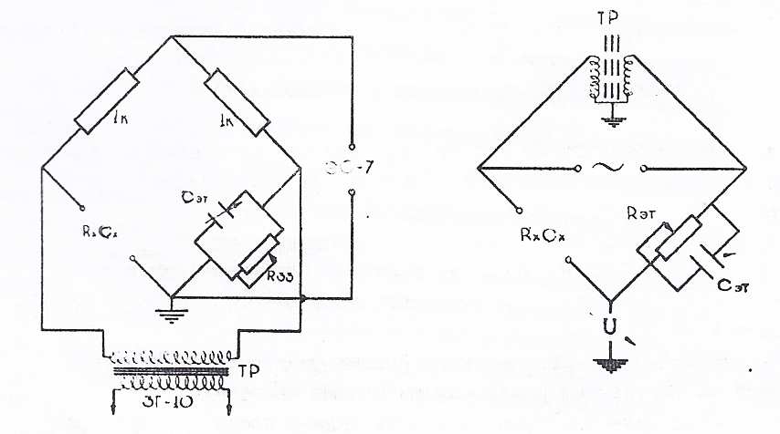

Fig. 1. Schematic diagrams of the low frequency and

high frequency AC bridges.

Active resistances were connected to the two arms of the low-frequency bridge, while a biological object and resistance standards were connected to the other two. An inductive connection was set between the arms of the high-frequency bridge. The alternators of low frequency current ZG-10 and high frequency current GSS-6 were the power sources for the bridges. The voltage applied to the tissue did not exceed 0.5 V. The electronic oscilloscope EO-7 served as an indicator of bridge settings.

Measurement of the tissues' electrical resistance was conducted as follows: the animal was decapitated, the test organ was removed, slightly dried with filter paper and superimposed on the platinum electrodes of the measuring cell, where constant humidity was maintained. Resistance of the biological object was compensated by the standards of the ohmic and capacitive components of the impedance of the known arm of the bridge. Resistance of the tissue was considered being balanced with the electrical resistance of the standards while reducing the amplitude of the oscilloscope sinusoid to a straight line.

The resistance was measured in the range of low (0.5, 1, 6, 10, 20 kHz) and high (100, 200, 400, 600, 1000 kHz) frequencies. Using ohmic resistance and electrical capacitance (R and C), there were calculated the resistivity ($ρ=\frac{RS}{l}$), where S is the electrode area, *l* is the distance between the electrodes), dielectric constant ($ϵ= \frac{с4πl∙9∙{10}^{11}}{S}$), where S is the electrode area, l is the distance between the electrodes, impedance ($Z= \frac{1}{\sqrt{(\frac{1}{R})^{2}+(WC)^{2}}}$, where ω is the circular frequency; the dielectric loss tangent (tgƷ = $\frac{1}{2πfRC}$, where f is the frequency of the alternating current); and the polarization coefficient (K = $\frac{R_{{10}^{4}}}{R_{{10}^{6}}}$, where R 104and R 106 are the ohmic resistance of the tissue at frequencies 104 and 10 6. Digital material was processed statically.

The general irradiation of rats was carried out on a radiotherapy unit RUM-II under technical parameters: 185 kV generation voltage, current 15 mA, 80 cm skin-focal distance, without tube, filter 0.5 mm Си + I mm A1, dose rate II R/min. and the total dose of 600 R. Pigeons were irradiated with a dose of 600 R And 1300 R.

Isolated blood irradiation was carried out according to the method by prof. A.I.Nesis (copyright certificate No.213985, priority date July 13, 1966). 1.5-3 cm3 of blood was taken from the main axillary vein of the pigeon, then the blood was mixed with 0.5 ml of 0.5% oxalic acid sodium solution in a special sterile vial, which was irradiated using the radiotherapy unit RUM-II at the voltage of 185 kV, current 15 mA, dose rate 300 R/min, the anode X-ray tube distance to the blood level in the vial was 24 cm, without tube and filter, irradiation dose 100000 R.

The isolated irradiation of pigeons' blood was carried out once, twice or three times, in the last two variants with 10-day intervals between the sessions of radiation exposure. After each irradiation session, the blood was injected back into the main axillary vein of the same pigeon,

Solar irradiation of animals was carried out in the summer, from the first day after the general X-ray exposure, every other day, 19 - 22 sessions each. The exposure of one session of solar irradiation corresponded to 14 - 15 minutes, and the total dose for the entire insolation period was 400 - 450 cal/cm2.

Physical activity of the rats was carried out on a specially designed treadmill (H.H.Irgashev, 1966) for small laboratory animals, with the treadmill length of 150 cm and the conveyor belt speed of 17 m/min. The animals were exposed to the 30-minute load already from the first day following X-ray irradiation, every other day, 10-15 times each.

In the literature, there is only scarce information about changes in the electrical conductivity of body tissues after ionizing impact (A.Polivoda, 1957; E. Burlakova e.a., 1960-1965; N. Aladzhalova, 1960; A.Portela e.a. 1960; A. Mikhailova, 1961; D. Lebedeva, 1966; *K. — R. Trott, 1969,* e.a.).

Own

research

Because of this, there was a necessity to conduct a series of experiments to determine the nature of shifts in the resistance values of various tissues following total-body X-ray irradiation of animals. The electric resistance was measured on day 1, 3, 6, 12 and 20 following the total-body sub-lethal radiation exposure.

Changes in the magnitude of the electrical parameters of tissues were observed already on the first day following the irradiation of animals. Ohmic resistance of the heart muscle decreased in the low frequency range (0.5–20 kHz) by 8–13%. The polarization coefficient equal to 5.2 in control, decreased to 4.8 on the first day after irradiation. On the contrary, the electrical capacity of the heart of irradiated rats was elevated.

Subsequently, the ohmic resistance of the heart muscle continued to decline and till day 20 following irradiation it fell at low frequencies by 9–18%. Moreover, the difference between the values of resistance in control and experiment became statistically significant (Р <0.005 - 0.05). For example, at frequency of 6 kHz, the ohmic resistance of the heart in control was 5120 $±$ 177 ohms, and by day 20 it was 4470 $±$ 135 ohms in irradiated rats (significance of the difference P <0.001).

On all days of the study, the polarization coefficient of the heart in the experimental series remained reduced compared with the control. After general x-ray irradiation of animals, the electrical capacity of the cardiac muscle increased, but by the end of the study, on the contrary, it became somewhat decreased. This circumstance predetermined the increase in the tangent of an angle of dielectric losses of the heart.

Simultaneously, changes in the electrical parameters of the liver developed. However, these shifts in irradiated animals occurred faster and reached higher values (Fig. 2). Thus, the ohmic resistance was significantly reduced already on day 6 following the general exposure (by 14–20%, P <0.001< 0.002), and on the 20th day the difference reached 28% (P< 0.001).

After the total irradiation of animals, the polarization coefficient of the liver is equal to 10.2 in the control, decreased to 8.8 on the 20th day of the study. During the same period, the high-frequency electrical capacity of the liver (P <0.007<0.05) statistically significantly decreased in the irradiated rats to 14% compared to control.

Shifts in skeletal muscle parameters of irradiated rats had a slightly different direction. The ohmic resistance of the muscles in the experimental series that decreased in the first days, increased in the remaining days of the study. For example, on day 6 after general irradiation at frequency of 1000 kHz, the resistance of skeletal muscles corresponded to 347 $±$ 13 ohms (control - 306 $±$ 6 ohms, P <0.01).

After radiation exposure, the electrical capacity of skeletal muscles at high frequencies fell for the entire study period. Moreover, in the first days after irradiation, the capacity decreased particularly sharply - by 15-24% (P <0.001 <0.05). In particular, at frequency of 1000 kHz, it corresponded to 172 $±$ 8 pF, and in the experimental series C = 131 $±$ 14 pF (P <0.001).

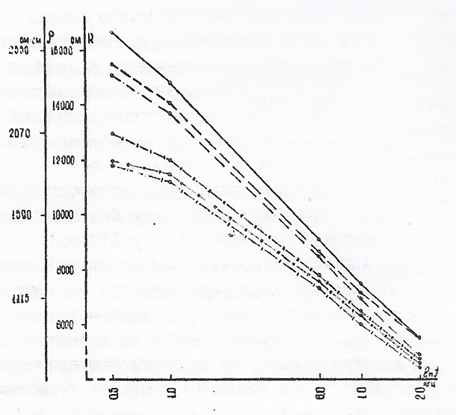

Fig. 2 Low-frequency ohmic resistance of the liver at various times after total x-ray irradiation of rats.

__________________________ CONTROL

__. __. __. __. __. __ day 1

__. __. __. __. __. __ day 3

__. __. __. __. __. __ day 6

__. __. __. __. __. __ day 12

__. __. __. __. __. __ day 20

The polarization coefficient of skeletal muscles decreased on the first day after the total irradiation of animals, relative to the control (K = 5.6), to 4.6. However, later, the coefficient in the experimental series gradually increased and reached 6.3 on the 20th day after the general radiation exposure on the rat.

The ohmic resistance of the spleen of irradiated animals also increased, especially at high frequencies (100–1000 kHz), with subsequent increase as the period after irradiation increased.

On the contrary, the high-frequency electrical capacity of the spleen in irradiated rats decreased. The maximum change of the capacity occurred on the 20th day after the total irradiation of them (by 20-23%, P <0.004 <0.04). For example, the electrical capacity of spleen in the control at frequency of 100 kHz was 169 $±$ 9 pF, and in the experimental series (on the 20th day of the study) - 135 $±$ 8 pF. The polarization coefficient of spleen of irradiated rats was reduced on all days after radiation exposure.

Shifts in electrical parameters of irradiated rats were also observed in studies of the kidneys, lung tissue, brain, sciatic nerve etc.

Such changes in the electrical conductivity of tissues under the influence of ionizing radiation are considered by many authors as a consequence of disturbances in submicroscopic structures. According to some authors, shifts in low-frequency ohmic resistance are caused by damage to membrane structures and the increased membrane permeability (N. Waterman, 1922, 1928*;* P. Mendeleeff, 1926; Portewla e.a. 1960; Yu. Vinetsky, 1962; Z. Nakhilnitskaya, 1965; V. Bogomolets and V. Mayskiy, 1966; B. Polivoda and co-author., 1972, e.a.), and in the opinion of others this is due to the disintegration of protoplasm and an increase in the number of low molecular weight particles (A. Polivoda, 1957; A. Mikhailova, 1961; B. Tarusov, 1962; E. Burlakova e.a., 1960-1965).

The change in polarization coefficient proposed

by B.N. Tarusov (1938), the increase in the loss tangent of an angle , as well as the decrease in the high-frequency capacity of the tissues, are, according to a fair statement of A.I. Polivoda (1957), "a reliable and characteristic sign of radiation injury."

Thus, the possibility of applying the impedance measurement method to clarify the nature of changes in various tissues of the irradiated organism is obvious. Moreover, by means of electrical conductivity it is possible to detect certain changes in all periods of radiation sickness.

Subsequent experiments were carried out to determine the severity of violations in the tissues with a combination of total ionizing radiation with some additional loads (multiple solar lighting, muscle tension, isolated blood irradiation).

Solar irradiation of rats caused some increase in ohmic resistance in the heart muscle at low frequencies, as well as a decrease of the polarization coefficient. In parallel, the ohmic resistance of skeletal muscles increased. On the contrary, the electrical resistance of the liver decreased. Moreover, the difference at frequency of 0.5 kHz is statistically significant (P <0.05). The electrical parameters of other organs and tissues also changed.

The effect of multiple solar lighting.

The effect of total x-ray irradiation and multiple insolations

A more severe picture of radiation sickness developed when combining X-ray and solar radiation. The death of animals irradiated with X-rays was 24%, and with additional insolation for the same period of time (1.5 months), the lethality of rats increased to 42%.

In rats of this series, the ohmic resistance of the heart decreased to a greater extent than after X-ray radiation alone. The high-frequency electric capacitance fell particularly sharply (relative to the cardiac capacity in rats subjected to X-ray exposure only by 11–20%, P <0.001 <0.009). So, at frequency of 1000 kHz, the electrical capacitance of the heart after total X-ray irradiation corresponded to 100 $±$ 2 pF, and when exposed to x-rays and sunlight, 82 $±$ 3 pF (P <0.001).

The coefficient of polarization of heart with a combined effect on rats decreased to 4.6 (in those irradiated with X-rays only, K = 5.2, in the control K = 5.4). The tangent of an angle of the dielectric losses of animals subjected to x-ray irradiation and insolation at frequencies of 6–1000 kHz exceeded the value of tgƷ in rats irradiated only by x-rays.

While studying the parameters of skeletal muscles, this dependence is even more clearly revealed. The low-frequency ohmic resistance of the muscles in the combined series is much lower (Fig. 3), both in relation to the control (by 20-25%, P <0.002<0.02), and in comparison with the tissue resistance of animals irradiated only by X-rays (by 28-33%, P<0.001<0.002).

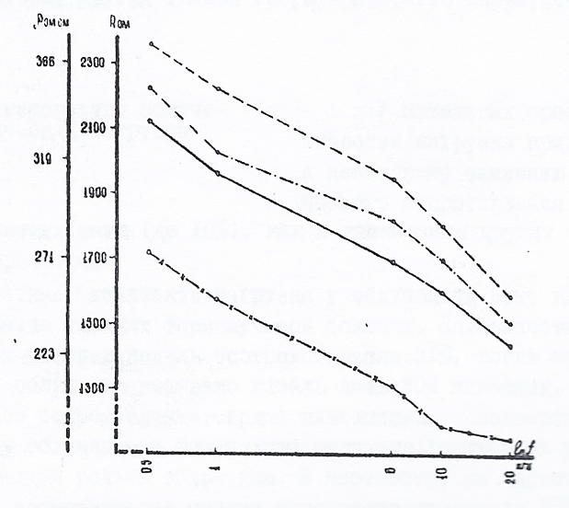

Fig. 3 Low-frequency ohmic skeletal resistance

muscles of rats after general X-ray exposure and

multiple insolations.

_____________________CONTROL

__ __ __ __ __ __ INSOLATION

__ __ __ __ __ __ X-RAY IRRADIATION

__. __. __. __. __ .X-RAY, RADIATION, INSOLATION

On the contrary, the electrical capacitance of the muscles of rats subjected to x-ray irradiation and insolation increased accordingly. The coefficient of polarization of muscle tissue decreased from 4.6 in the control to 3.8, while after general X-ray exposure K = 5.2. The tangent of an angle of the dielectric losses increased with respect to the control and the animals exposed to penetrating radiation.

The electrical parameters of the liver changed equally after joint X-ray irradiation and insolation, as well as after general ionizing impact only. But in the spleen there was a significant decrease in the high-frequency electrical capacitance in the combined series with respect to this parameter in animals under only to X-ray exposure. The same data were obtained by us in the study of the electrical conductivity of some other tissues (peripheral nerve, kidneys, etc.).

The effect of X-ray exposure and physical loads

Physical activity leads to some decrease in the ohmic resistance of the heart and skeletal muscles of intact rats (down to 10%), same as to changes in other electrical parameters.

Repeated physical loads of irradiated rats entailed the development of severe forms of radiation sickness. The lethality of rats in three to four weeks amounted to 31%, while X-ray irradiation alone caused the death of only 20% of animals.

The ohmic resistance of the heart of animals subjected to x-ray irradiation and physical exertion decreased more sharply than that of the animals exposed only to irradiation. In particular, at frequency of 100 kHz, the ohmic resistance of the heart of rats was 1890 $±$ 57 Ohm, whereas in the animals irradiated and subjected to exercise stress it was 1750 $±$ 38 Ohms. A difference of 140 ohms is statistically significant (Р<0.05).

The polarization coefficient of the heart in the combined series was 4.6, while with irradiation only it was 5.0. The tangent of an angle of the dielectric losses of the heart muscle at the same time increased both in comparison with the control, and with a series of experiments using only x-ray irradiation (Fig. 4).

The ohmic resistance of skeletal muscles in irradiated rats subjected to repeated physical exertion was reduced, compared to the just-irradiated animals, by 12–13% (P<0.007 0.02).

At the same time the electrical capacity in the combined series has increased. The coefficient of polarization of the muscles was 5.6 in the control, and in the animals irradiated with X-rays was 6.3, while under physical loads after irradiation, on the contrary, this coefficient decreased to 5.5.

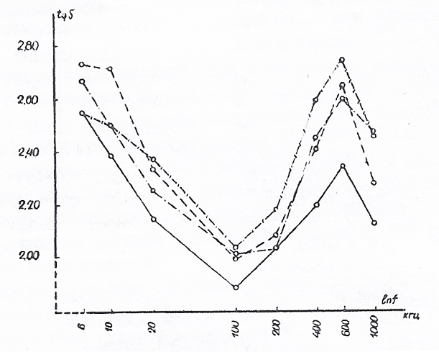

Fig. 4. The tangent of an angle of the losses of heart muscle in rats after

general X-ray exposure and performing

repeated physical exertions

_____________________CONTROL

__ __ __ __ __ __ PHYSICAL LOAD

__ __ __ __ __ __ X-RAY IRRADIATION

__. __. __. __. __.PHYS. LOAD, X-RAY IRRADIATION

The liver of rats in combined series had high ohmic resistance in comparison with just irradiated animals only (at frequencies of 0.5–20 kHz by 18–34%, (P<0.0010.005), and also in relation to the control (up to 12%, P<0.02). On the contrary, the high-frequency electrical capacity of the liver is inversely related.

Thus, the results of our experimental studies of electrical parameters allow us to conclude about the adverse effect of physical load on animals exposed to x-rays.

A completely different nature of changes was obtained with a combination of transfusions of insulated irradiated blood and the total-body radiation exposure.

The impact of transfusions of isolated irradiated blood and the general radiation exposure on the body.

It should be emphasized that the tolerance to transfusions of isolated irradiated blood (IIB) was established, including the method of extracorporeal radiation exposure (ECRE), even with very large doses (E.P.Cronkite, E.A., 1962; L.Y.Lajtha e.a., 1962; A.I. Nesis e.a., 1966-1974, and others)

In measurements of the impedance of tissues of pigeons, whose blood was subjected to intense ionizing exposure, moderate changes were also detected, but the difference with control was, as a rule, not statistically significant.

Transfusions of isolated irradiated blood prevented the development of a strong pattern of radiation sickness following subsequent general exposures of the body to sub-lethal doses.

Obviously, it is necessary to note here the interesting results of research by I.B.Rukhman and Z.D.Jalalov (1972), who received a similar effect, exploring the bone marrow and peripheral blood.

In the experiments of L. A. Zhavoronkova (1974), the total X-ray irradiation of male rabbits by dose of 800 R caused practically irreversible functional and morphological shifts in the genital sphere, whereas preliminary radiation impacts on the blood have largely prevented such disorders.

In our studies, the total irradiation of part of pigeons by dose of 1300 R caused mortality in 73.6% of birds during 4 months of observation. On average, their lifetime was 44.0 days. A preliminary single transfusion of isolated irradiated blood reduced the mortality of birds from the same dose (1300 R) of general irradiation down to 44.4%. At the same time, the lifetime of these pigeons increased up to 65.6 days. The lethality of pigeons in the case of two – threefold preliminary IIB and subsequent general radiation exposure under the same dose during the same four months was 57.8% and 52.9%. The lifetime of the same birds was on average 59.7 and 56.1 days.

In experiments with the general irradiation of the body by dose of 600 R and a single isolated radiation impact on the blood, the pigeons retained their ability for orientation and navigation, the flight time of a certain distance was reduced and the excitability of the vestibular apparatus suffered less (R.D. Jabbarov, 1972).

Research in electrical conductivity of the tissues of the same birds confirmed a certain prophylactic effect of transfusion of isolated irradiated blood during subsequent radiation loads on the entire body. The low-frequency ohmic resistance of the cardiac muscle in pigeons with preliminary IIB and subsequent general irradiation decreased in relation to control by only 3–5%, while in comparison with the birds exposed only to general irradiation, an increase to 12% was observed.

The high-frequency electrical capacitance of the pigeon heart muscle in the combined series is close to the value of the capacitance in control, i.e., is 17-28% P <0.001<0.04 higher than that of the generally irradiated birds. In this regard, the pigeons of the combined series showed less pronounced changes in the tangent of an angle of the dielectric losses. For example, at frequency of 200 kHz, the tangent of an angle of the losses of heart in the control was 2,12 only under isolated irradiation of blood tgƷ= 2.20, and after the total x-ray irradiation of birds, this indicator increased to 2.48.

In cases of preliminary IIB and subsequent general irradiation of the body, the corresponding parameter was equal to 2.17, that is, close to control, and this pattern was invariably noted at all frequencies studied.

The polarization coefficient of the heart in generally irradiated pigeons has dropped to 2.8 (control K = 3.0), in the combined series, on the contrary, it rose to the level of 2.95.

We obtained similar results while studying the electrical characteristics of the liver. Under the impact of general X-ray exposure of the body, they have changed significantly. In cases of preliminary isolated blood irradiation, the subsequent irradiation does not cause such sharp changes in the electrical conductivity of the liver tissue. The ohmic resistance of the liver in the combined series at frequencies of 0.5–20 kHz decreased by only 3–7% (Fig. 5).

The difference with control is not statistically significant (P> 0.13). In comparison with the resistance of the liver in birds exposed only to general irradiation, the ohmic resistance in the combined series increased within the same frequency range by 12-27% (P> 0.01> 0.005).

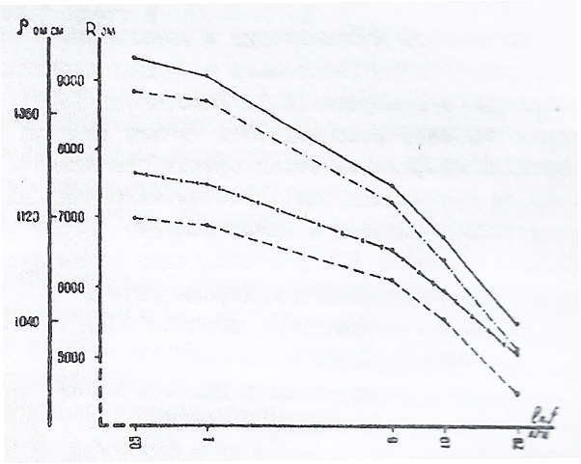

Fig. 5 Low-frequency ohmic resistance of the liver

in pigeons following isolated blood irradiation

and total irradiation exposure

_____________________CONTROL

__ __ __ __ __ __ IIB

__ __ __ __ __ __ TOTAL IRRADIATION

__. __. __. __. __ IIB, GENERAL IRRADIATION

For example, at frequency of 0.5 kHz, the ohmic resistance of the liver of pigeons subjected only to total irradiation exposure was 6990 $±$ 201 Ohms. If the blood was previously irradiated (outside the body), the liver resistance increased to 8870 $±$ 325 Ohms (the difference in 1880 Ohms is statistically significant, Р>0,001). In the control series, the ohmic resistance is 9300 $±$ 385 ohms.

The polarization coefficient of the liver in pigeons within combined series was 7.8, and was less than the value of the coefficient in control (K = 8.2).

After only total irradiation of birds, this coefficient was 6.9. Similar changes in electrical conductivity in the combined series of experiments were noted in other organs and tissues too.

Consequently, our data confirm the results of the above-mentioned complex research, and suggest that preliminary transfusion of isolated irradiated blood is a stimulating and non-specific prophylactic agent against general irradiation, mitigating the severity of radiation sickness.

CONCLUSIONS

1. General X-ray irradiation leads to the development of certain changes in the electrical conductivity of tissues. The electrical resistance of each type of tissue changes already on the first day after the total irradiation load. As a rule, the difference with the control becomes maximum during the height of radiation sickness.
2. Under the general X-ray irradiation of the organism, in the heart muscle and liver low-frequency ohmic resistance and polarization coefficient, and, to a lesser extent, electrical capacitance decrease, while the tangent of an angle of the dielectric loss increases. In the liver, these changes peak at the sixth, and in the heart muscle on the twentieth day after total irradiation. As a rule, the ohmic resistance of skeletal muscles and spleen increases.
3. The combined total x-ray and solar irradiation of rats, in contrast to the isolated action of each of these factors, causes a sharp decrease in the low-frequency ohmic resistance, high-frequency electrical capacitance and the polarization coefficient of the heart muscle; the tangent of an angle of the loss of heart muscle loss, on the contrary, increases to the same extent. An even clearer decrease is observed in ohmic resistance and the polarization coefficient of skeletal muscles, as well as the high-frequency electrical capacitance of the spleen.
4. Physical exertion in rats irradiated with x-rays helps to reduce the low-frequency ohmic resistance and the polarization coefficient of the heart and skeletal muscles, increase the ohmic resistance of the liver, and also lower its high-frequency electrical capacitance.
5. Transfusion of isolated irradiated blood (IIB) to pigeons does not entail changes in the electrical conductivity of tissues characteristic of radiation sickness. There is a slight difference between the values of the electrical parameters of the studied objects in the control and after transfusions of isolated irradiated blood, which, as a rule, is not statistically significant.
6. Transfusion of isolated irradiated blood reduces mortality and increases lifetime of pigeons, subsequently subjected to general irradiation by sub-lethal doses. Indicators of low-frequency ohmic resistance, polarization coefficient, the dielectric loss tangent of the liver and cardiac muscle, as well as some other organs, with isolated blood irradiation and the subsequent general X-ray exposure are close to the control parameters.
7. Experimental studies have shown the negative impact of multiple solar lighting and physical loads X-ray-irradiated animals.

On the contrary, the transfusion of intensely irradiated autologous blood is a definite preventive agent in cases of subsequent general irradiation.

**List of scientific publications on the topic of the dissertation**:

1. The research of the electrical conductivity of the renal tissue of irradiated animals. Materials of the XII student conference of Central Asia and Kazakhstan dedicated to the 99th anniversary of V.I. Lenin (April 16 - 19, 1969, Frunze). 1970, p. 76.
2. The impact of physical load on the electrical parameters of rat heart muscle. Allergy and allergic diseases in Uzbekistan. Interinstitutional collection of scientific works. Tashkent, 1971.p.98 (in collaboration).
3. Electrical and morphological condition of the sciatic nerve in rats of the same age under physical exertion. All-Union Scientific Conference on Age Morphology. December 12-14, 1972. Theses of reports, Samarkand, 1972 vol.II. p. 41 (co-authored).
4. Electrical parameters and morphological structure of skeletal muscles and nerve endings after repeated physical load. All-Union Scientific Conference on Age Morphology December 12-14, 1972. Theses of reports. Samarkand, 1972, t. II, p.42 (in collaboration).

5. Effect of combined x-ray and solar irradiation on the electrical characteristics of skeletal muscle. Ways to increase the productivity of farm animals and birds (The impact of physical agents on the animal organism). Collection of scientific works. Odessa, 1972, p.573 (in collaboration).

6. The effect of insolation and high temperature on the electrical parameters of rat heart muscle. Theses of the third scientific conference of the central research laboratory (CRL) April 13-14, 1972. Samarkand. 1972. p. 40 (co-authored).

7. The combined effect of X-ray and insolation on some electrical characteristics of the peripheral nerve. Psychopathology, psychotherapy, psychology. Almaty 1972.p.34.

1. The impact of physical exertion on the electrical parameters of rat heart muscle. Non-contagious diseases of farm animals and measures to combat them. Samarkand, 1972, p.89 (in collaboration).
2. The effect of extracorporeal irradiation of the blood and the whole body on the electrical properties of the heart muscle. Documents of scientific conferences. Samarkand, 1972, p. 103 (co-authored).
3. On search for ways of immunization in the prevention of radiation sickness. Research of young medical scientists of Uzbekistan. Tashkent, 1973, v. 3, p. 329 (co-authored).
4. The effect of combined extracorporal blood irradiation and total X-ray irradiation on the electrical properties of the liver. Works of young medical scientists of Uzbekistan. Tashkent, 1973, v. 3, p. 331 (co-authored).

12. Electrical characteristics of the heart and skeletal muscles of pigeons against the background of an isolated X-ray impact on blood. Collection of research works of the Central Scientific Research Laboratory of Medical Universities of Uzbekistan. Tashkent-Samarkand, 1973. v.1, p. 211 (in collaboration).

The dissertation materials were reported and discussed:

1. On XXXV, XXVI, XXVII and XXVIII scientific student conferences of the Samarkand Medical Institute (1967-1970).

2. On the XVII final student scientific conference of the Altai State Medical Institute, Barnaul (1968).

3. On the XII student scientific conference of Central Asia and Kazakhstan, Frunze (1969).

4. On the I scientific conference of pathophysiologists, Samarkand (1971).

5. On the III Scientific Conference of the Samarkand Medical Institute (1971).

6. On the 60th scientific conference of the faculty of the Samarkand Medical Institute (1972).

7. On the intercollegiate scientific conference on the problem "The study of physical agents on the organism of animals" (Odessa, 1972).

8. On the I scientific conference of young scientists of the Samarkand Medical Institute (1973).

9. On the I scientific conference of young scientists of the Stavropol Medical Institute (1974).

___________________________________________________

AMINOV Boris Mikhailovich

ELECTRICAL PARAMETERS OF THE TISSUES UNDER COMBINED IMPACT OF

ON THE BODY OF SOME PHYSICAL FACTORS

(Exposure to general sub-lethal X-ray irradiation, insolation, physical exertion and transfusion of isolated irradiated blood)

14.00.16 - Pathophysiology

ABSTRACT

of the dissertation for the degree of

candidate of medical sciences

Signed to print on 2.08.1974

Printed sheet 1. Order *272.* Circulation 250 copies.

Publisher: Stavropol State Medical Institute.

310 Mira Street, Stavropol 355024.

Copying Department of the Stavropol Agricultural Institute. 347 Mira Street, Stavropol 355014